## Objective

**Predicting the sentiment from news headlines whether it will be positive, negative, or neutral.**

## Data

The data training model will contain news headlines and sentiment, while the will look like this:

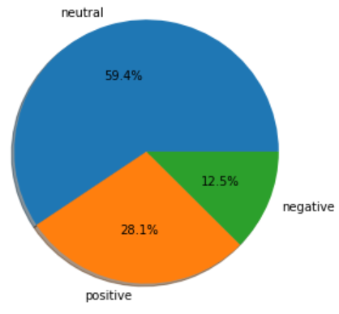

The test data to use to evaluate the model is containing only the news headlines column.

## Method

The data being predicted using BERT and transformers pre-trained data, then it will be evaluated by accuracy score.

## Model Result and Evaluation

The model gave 82.25% of accuracy score which indicated a good result (>80%). Here’s the confusion matrix table, with 0: Negative, 1: Netral, 2: Positive:

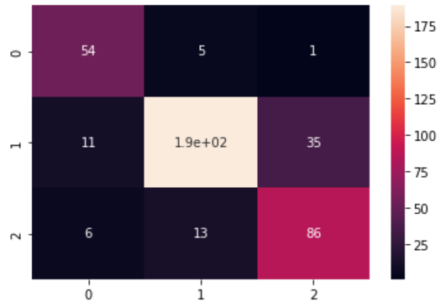

The test data news prediction from model is given below:

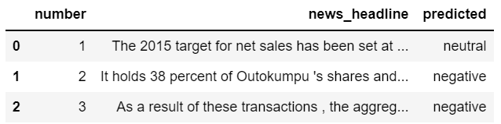

## Possible Improvement

* Tuning more for the data preparation such as implement SMOTE, also other data balancing might greatly improve the model output (Oversampling so we’re not going to lose any information).
* Tuning the BERT hyperparameter as I just used a simple parameter tuning.